Review of Java

Inheritance and Polymorphism
Inheritance: general classes can be specialized to more particular classes.
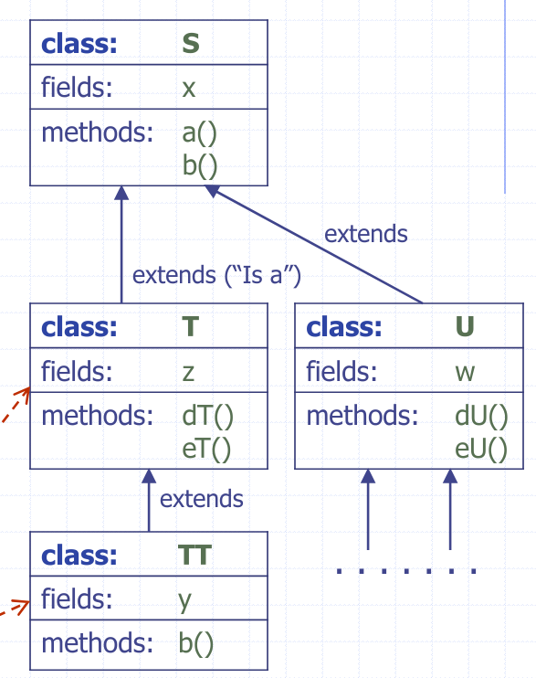
- Main purpose: reusing code.
- General class:
Base class, superclass
- Specialized class:
subclass
- We get: hierarchy of classes
Class T inherits x, a(), b() from S; extends S by adding z, dT(), eT().
Class TT inherits x, a(), z, dT(), eT(); overrides (specializes) b() from S.

Example
- Numeric Progressions:
  - Design classes for stepping through and printing out numeric progressions.
- Arithmetic progression
  - Defined by the first number (we assume it’s 0) and the common difference, e.g.: 0, 3, 6, 9, 12, …
- Geometric progression
  - Defined by the first number (we assume it’s 1) and the common ratio, e.g.: 1, 4, 16, 64, …
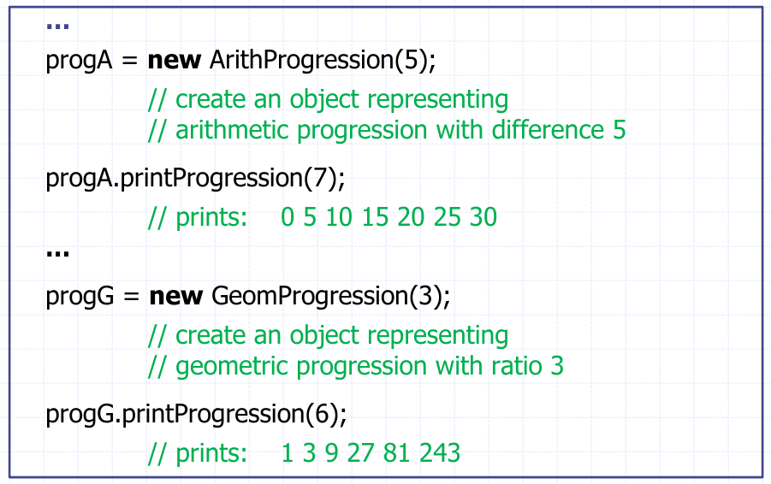
- Fibonacci progression: defined by the first number (we assume it’s 0) and the second number; each subsequent number is the sum of the previous two numbers. e.g.: 0, 3, 3, 6, 9, 16, …

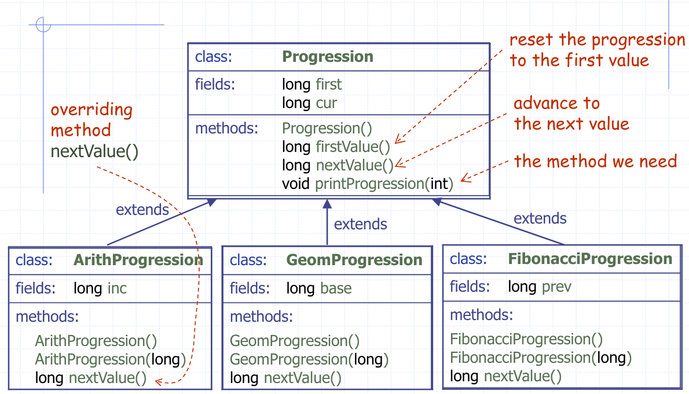
‘Progression’ class hierarchy

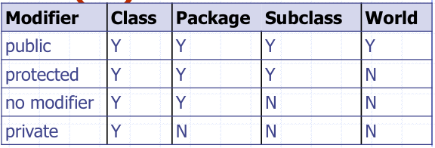
Class progression
package progress;
public class Progression {
protected long first;
protected long cur;
protected Progression() {
cur = first = 0;
}
protected long firstValue() {
cur = first;
return cur;
}
protected long nextValue() {
return ++cur;
}
//next value

public void printProgression(int n) {
System.out.print(firstValue());
for (int i = 2; I < n; i++) {
System.out.print(“” + nextValue());
}
System.out.println();
}
public static void main (String[] args) {
Progression prog = new Progression();
System.out.println(“Default progression: “);
prog.printProgression(10);
}
}

Class ArithProgression
class ArithProgression extends Progression {
//inherits fields: first, cur
protected long inc;
ArithProgression (long increment) {
inc = increment;
}
ArithProgression() {
this(1);
}
protected long nextValue() {
cur += inc;
return cur;
}
public static void main (String [] args) {…}
}

Class geomprogression
class GeomProgression extends Progression {
//inherits fields: first, cur
protected long base; // base (ratio) of the progression
GeomProgression (long b) {
base = b;
first = 1;
cur = first;
}
GeomProgression() {
this(2);
}
protected long nextValue() {
cur *= base;
return cur;
}
public static void main (String [] args) {…}
}

Class Fibonacciprogression
class FibonacciProgression extends Progression {
// inherits fields: first, cur
protected long prev;
FibonacciProgression (long second) {
prev = second – first;
}
FibonacciProgression() {
this(1);
}
protected long nextValue() {
long next = cur + prev;
prev = cur; cur = next; creturn cur;
}
public static void main (String[] args) { … }
}

Testing the progression classes:
>java TestProgression
Arithmetic progression with default increment: 0 1 2 3 4 5 6 7 8 9
Arithmetic progression with increment 5: 0 5 10 15 20 25 30 35 40 45
Geometric progression with base 3: 1 3 9 27 81 243 729 2187 6561 19683
Fibonacci progression with start values 0 and 4: 0 4 4 8 12 20 32 52 84 136
Polymorphism
Polymorphism: objects referenced by variables of the same reference type can have different forms.
- Objects referenced by variable Progression prog; can have different forms; Progression, ArithProgression, GeomProgression, FibonacciProgression

Consider: prog = new … ; //from class Progression
prog.printProgression(10);

Abstract classes
An abstract method – a method which has no definition (a method without a body).
An abstract class – a class which may have abstract methods.
- Abstract classes are used only as superclasses in inheritance hierarchies.
- These classes cannot be used to instantiate objects, because they are incomplete
Subclasses of an abstract class must declare the “missing pieces”.
- Classes that can be used to instantiate objects are called concrete classes.
- Such classes provide implementation for every method they declare, and for all abstract methods in superclasses.

Progression as an abstract class
Class Progression was “forced” to be a concrete class.
It should be an abstract class, as each progression is of a specific type.
public abstract class ProgressionAbstract {
protected long first, cur;
protected long firstValue() {
cur = first;
return cur;
}
protected abstract long nextValue();
//advances the progression to the next value
public void printProgression (int n) { …
for (int i = 2; i <= n; i++) {
System.out.print(“” + nextValue());
}
}
}

Extending abstract classes
class ArithProgression2 extends ProgressionAbstract
{ … } // in this case, everything else as before
class GeomProgression2 extends ProgressionAbstract {…}
class FibonacciProgression2 extends ProgressionAbstract{…}
class TestProgressionAbstract {
public static void main(String[] args) {
ProgressionAbstract prog;
prog = new ProgressionAbstract(5); // cannot instantiate // the type
// ProgressionAbstract
prog = new ArithProgression2();
System.out.println(“Arithmetic progression with default increment:”);
prog.printProgression(10);
…
}
}

Interfaces
Java interface is an ultimate abstract class. It may have only public abstract methods
Also static final fields (constants) and, from Java 8, static methods and default methods, all public; but we won’t use these possibilities.
- A class is said to implement the interface if it provides definitions for all of the abstract methods in the interface.

Progression as an interface
public interface ProgressionInterface {
public long firstValue();
public long nextValue();
public void printProgression(int n);
}
Subclasses must:
- declare all required fields and
- provide definitions (implementations) of all methods specified in the interface.
public class ArithProgressionIntF implements ProgressionInterface {
protected long first, cur, inc;
ArithProgressionIntF(long increment) {inc = increment;}
ArithProgressionIntF() {this(1);}
public long firstValue() { … }
public long nextValue() { … }
public void printProgression(int n) { … }
public static void main (String[] args) {
ProgressionInterface prog;
prog = new ArithProgressionIntF (5);
prog.printProgression(10);
}
}

Java 8
public interface ProgressionInterfaceJava8 {
int MAX_LENGTH = 100; //static and final → constant
public static void printMaxLength() {
System.out.print(“Maximum length: “ + MAX_LENGTH);
}
public long firstValue();
public long nextValue();
public default void printProgression(int n);
System.out.print(firstValue());
if (n > MAX_LENGTH) {
n = MAX_LENGTH;
}
for (int i = 2; i <= n; i++) {System.out.print(“” + nextValue()); }
}
}
With default methods, there is no need for printProgression in classes implementing this interface.

Interfaces and multiple inheritance
In Java: a class may extend only one other class. However, we may implement more than one interface.
public class Student { ... }
public class Employee { ... }
public class StudentEmployee extends Student, Employee {…}
public interface Student { ... }
public interface Employee { ... }
public class StudentEmployee implements Student, Employee {...}

Type conversions; casting
Widening (type) conversions: converting to a “wider” type.
- No problem.
Narrowing conversions: converting to a “narrower” type.
- ‘Casting’ necessary. (e.g. casting to a subclass, or subinterface)
e.g.:
Package java.lang provides classes that are fundamental to the design of the Java programming language.
This package includes:
public abstract class Number implements …
public final class Integer extends Number implements …
public final class Double extends Number implements …
… //there are other classes which also extend class Number

Generics
Usually with <> notation!
(think lists)
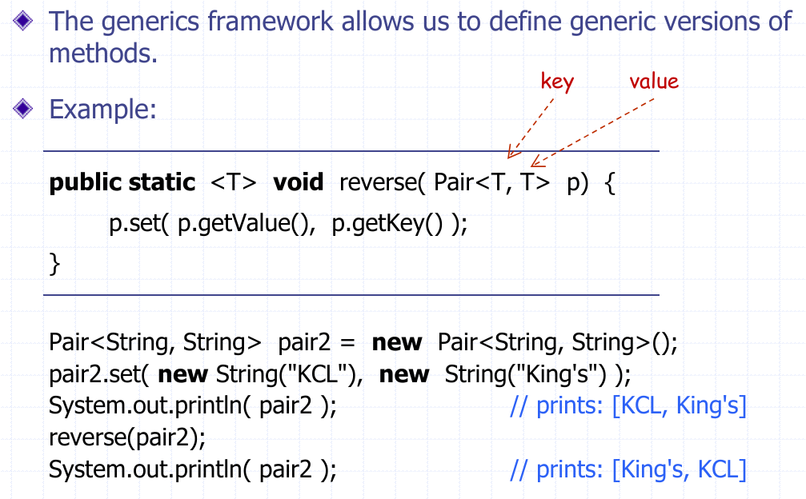

Linked lists

Specifying and implementing a data structure
- Data structure – A systematic way of organizing, accessing and updating data.
- Algorithm – a step-by-step procedure for performing some tasks
  - Algorithms use data structures. Data structures need algorithms for performing the tasks of accessing and updating data.
- Abstract data type (ADT) – a model of a data structure that specifies the type of data stored, the operations supported on them, and the type of parameters of the operations.
An ADT specifies what each operation does, but not how it does it.
- In Java, an ADT can be expressed byt an interface (and that’s the approach which we will use).
- An ADT is realized by a concrete data structure, which is implemented in Java by a (concrete) class.

Example: stack
- An instance of the stack data structure is a sequence of elements (objects with one end designated as the top of the stack): (E1, E2, E3, …, En)
Main stack operations:
- push(e): insert element e at the top of the stack
- pop(): remove and return the element at the top of the stack
Additional stack operations:
- top(): return the top element in the stack (without removing)
- size(): returns the number of elements stored
- isEmpty(): indicates if the stack is empty

Implementations of stack interface
public interfaceStack<E>{
public void push( E element );
public E pop() throws EmptyStackException;
public E top() throws EmptyStackException;
public int size();
public boolean isEmpty();
}
public class ArrayStack<E> implements Stack<E> {…}
public class NodeStack<E> implements Stack<E> {…}

Singly linked list
Linked list – An alternative to array for storing a sequence of objects
A singly linked list is a sequence of nodes
Each node stores
- element
- link to the next node
